*GIT & GiHub Assignment*

Section 0 :

Using GIT as local VCS.

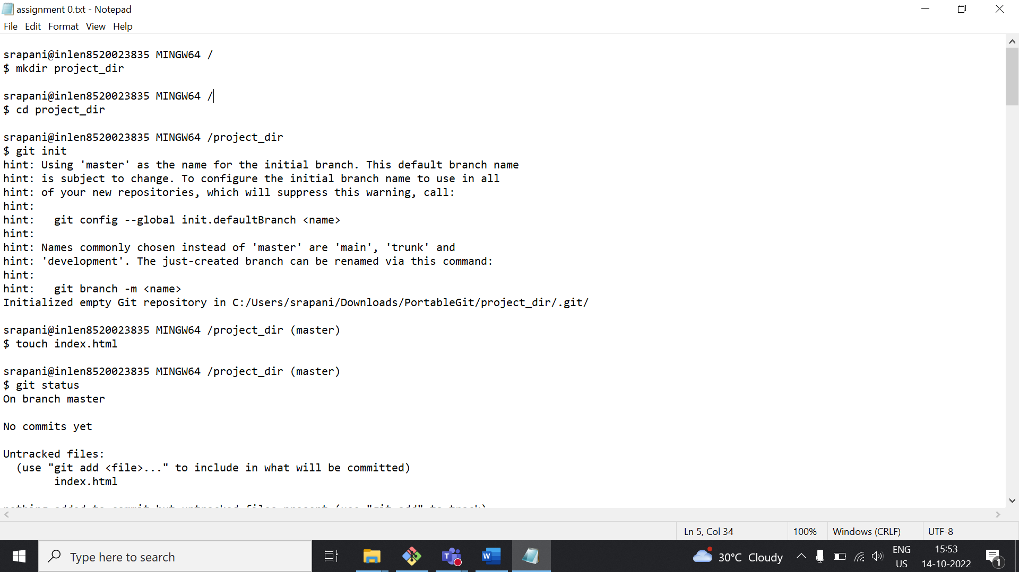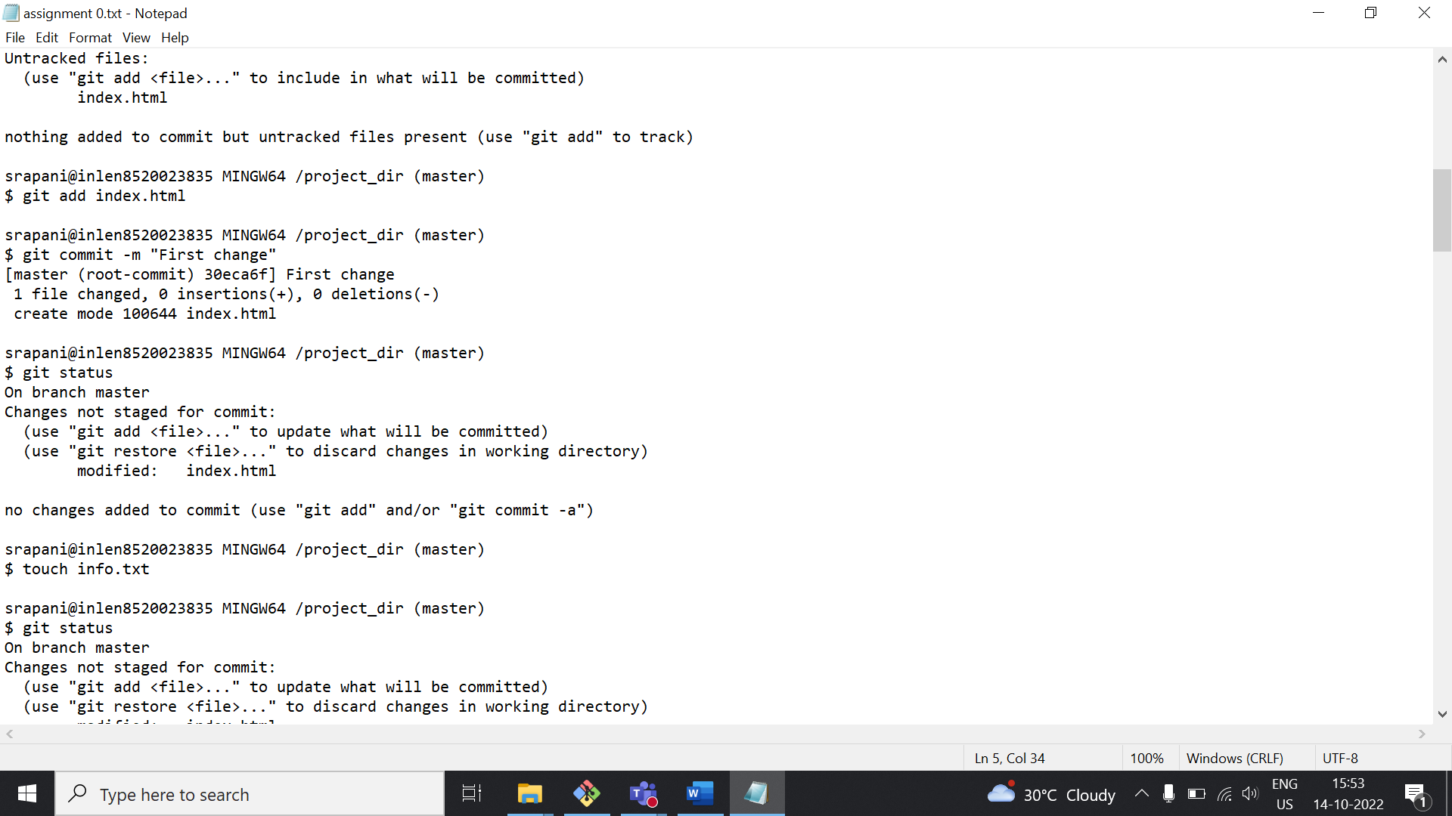

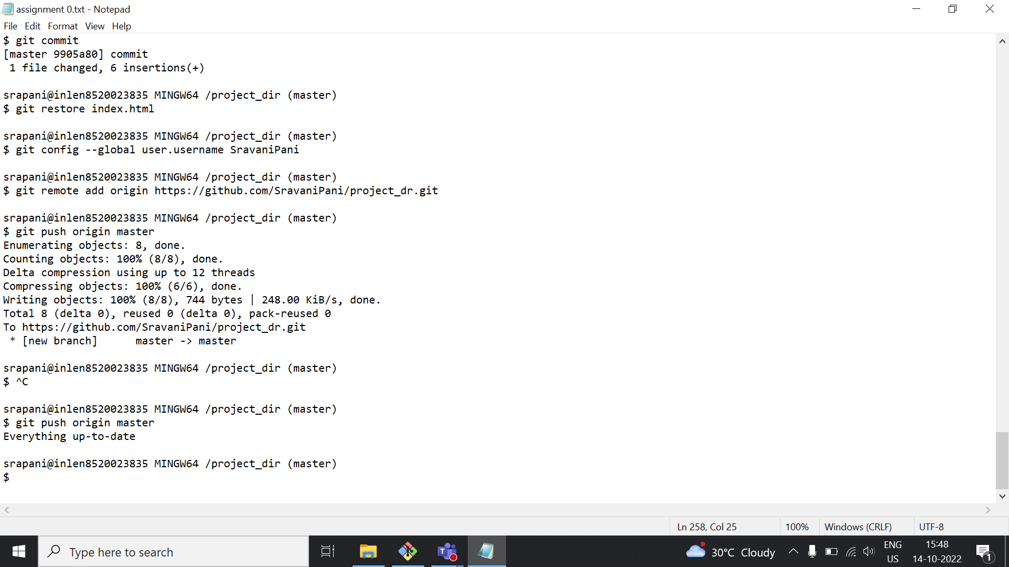

Click this link to view it in my GitHub account

<https://github.com/SravaniPani/project_dr.git>

Section 1,2,3

GIT Branching: Commit HTML, CSS & JavaScript assignments into GIT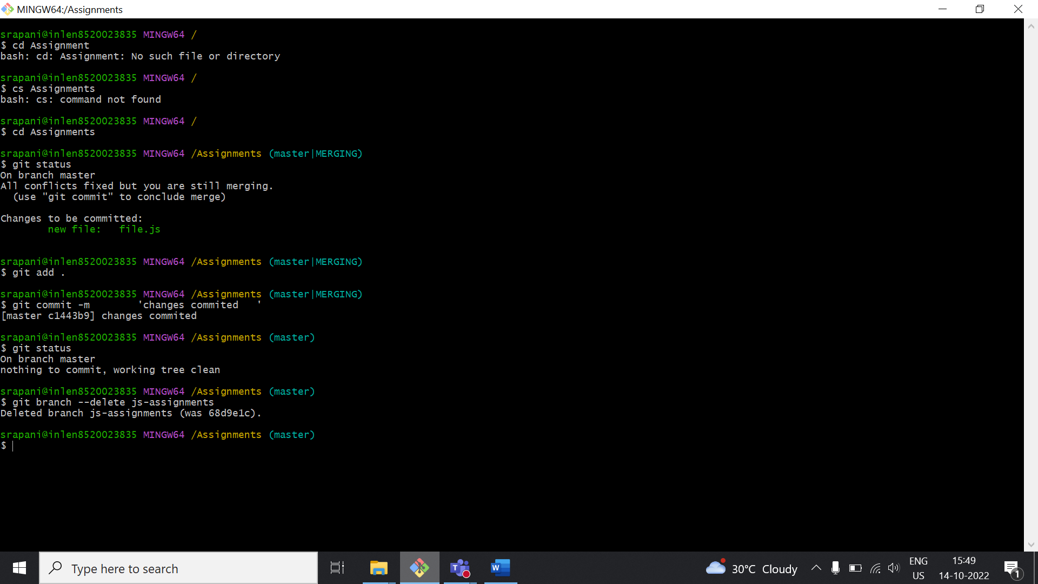

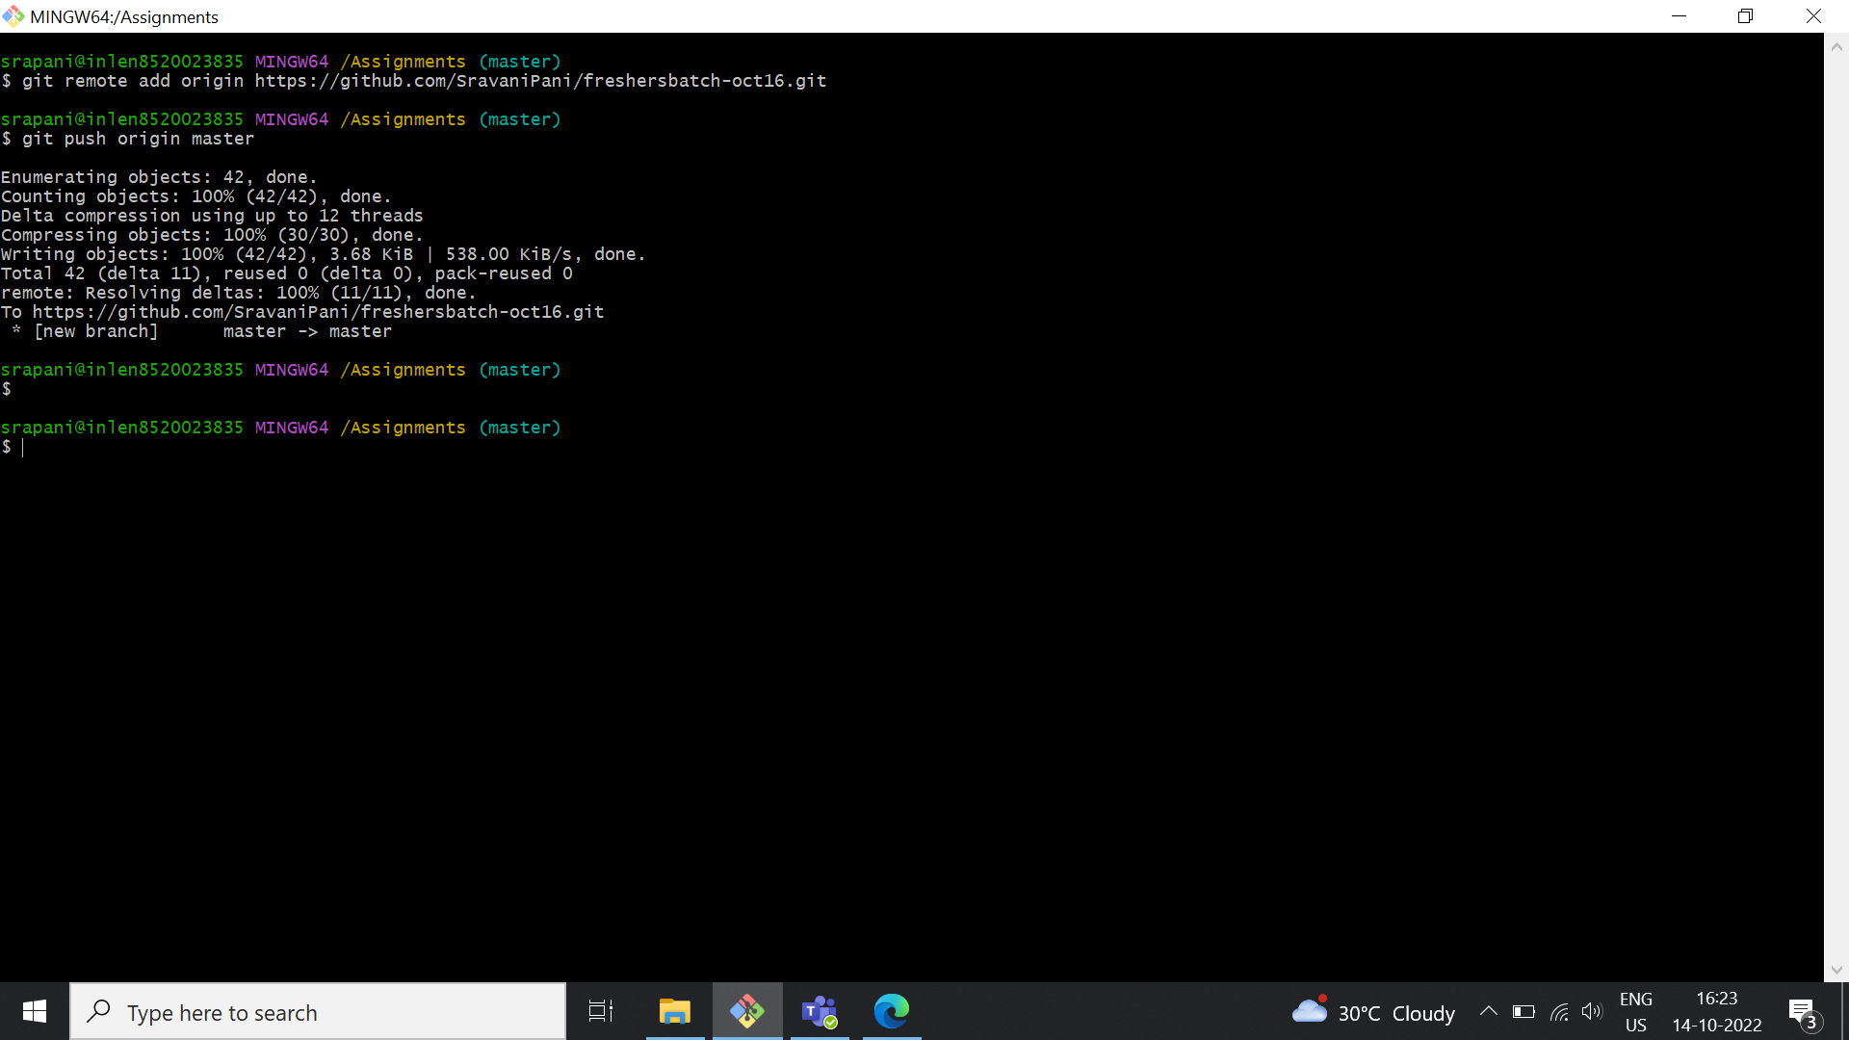

Click this link to view **“freshersbatch-oct16”** repository in my GitHub Account.

<https://github.com/SravaniPani/freshersbatch-oct16.git>

Section 4 :

Pushing source code to remote repository using Eclipse GIT plugin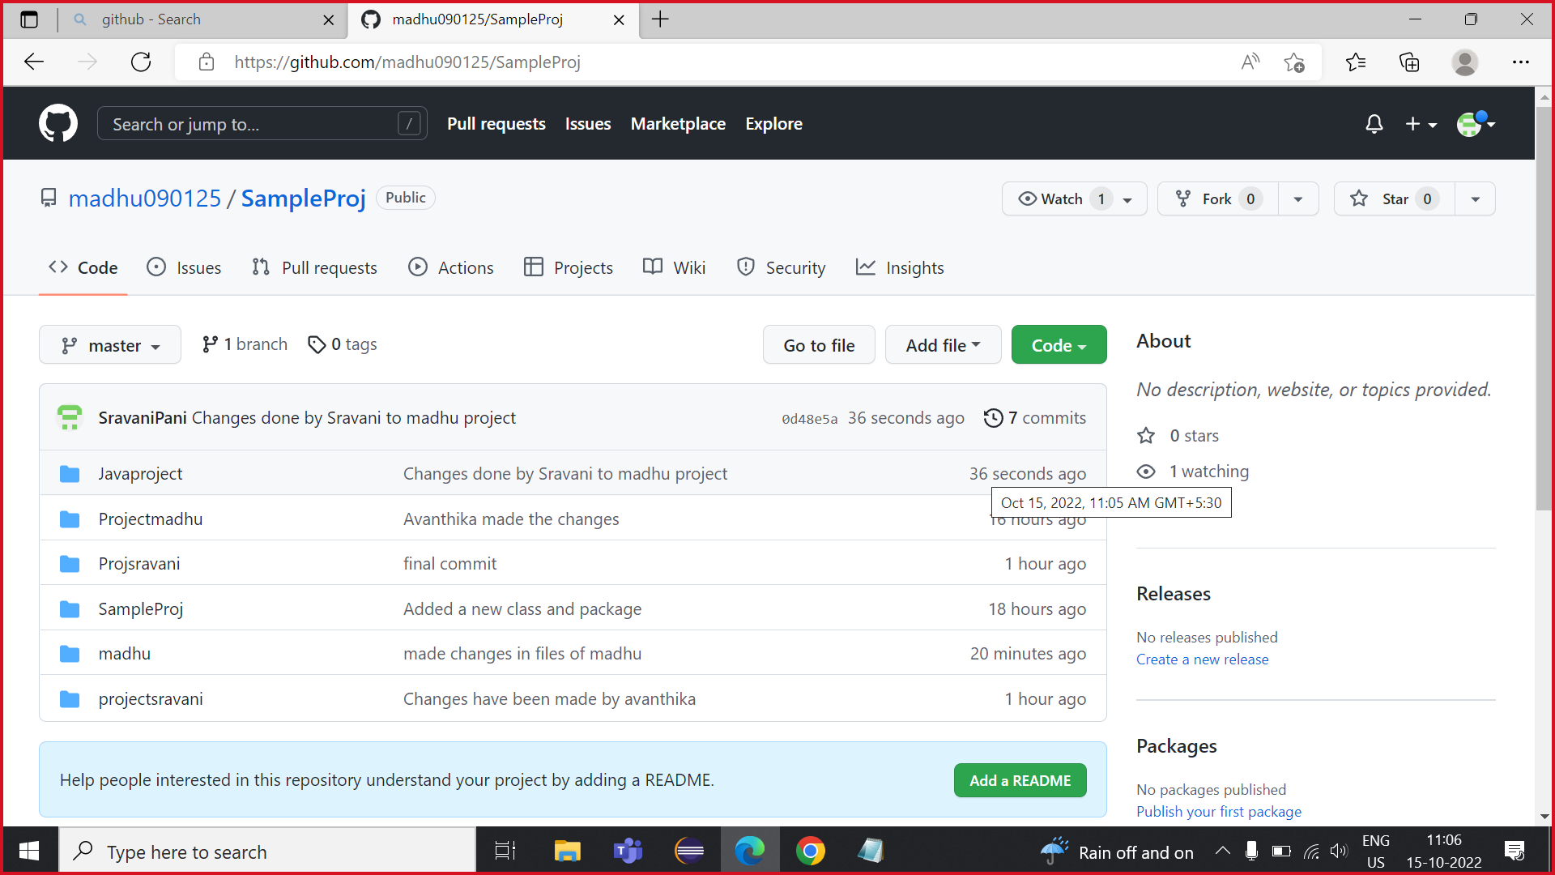

Collaborating with team members :

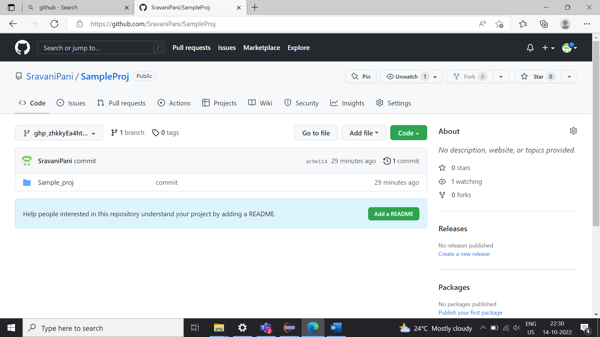

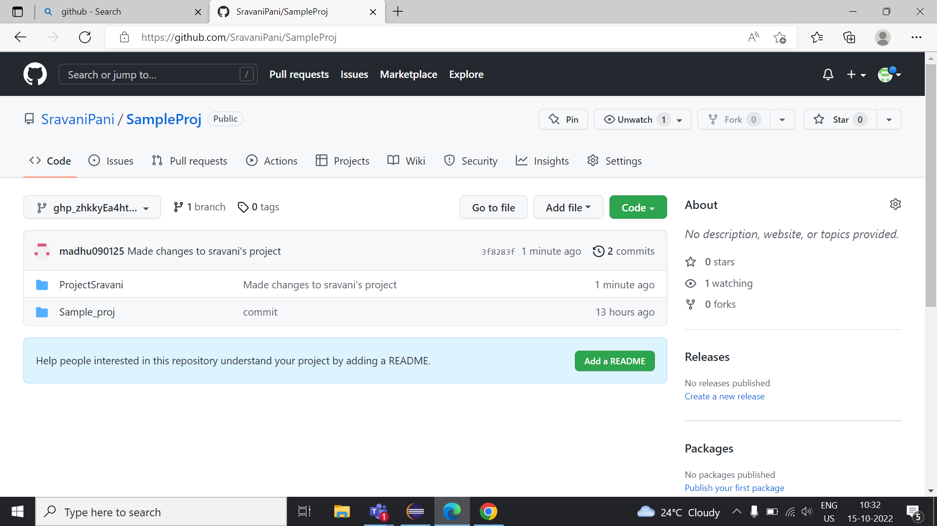

Successfully Completed the collaboration.